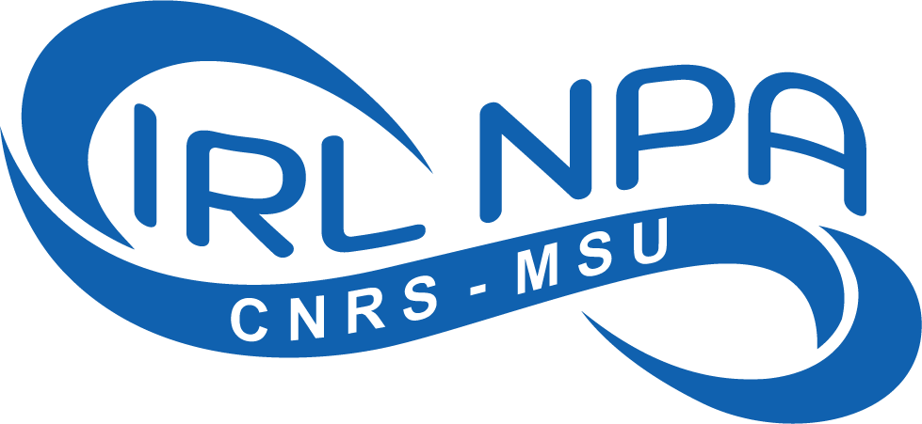 | International Research Laboratory for  Nuclear Physics and Nuclear Astrophysics  IRL-NPA  Centre National de la recherche scientifique (CNRS)  & Michigan State University (MSU)
Located at FRIB 640 S Shaw Lane East Lansing 48824 MI, USA

Visitor Information

Initial information needed for trip logistics, planning visit and travel, and for export control screening.

Full name (as per government-issued ID):
Arrival Date at FRIB:
Departure Date from FRIB:
Country of Citizenship:
Visa Status:

Home Institution name:
Home institution address:
Business email address:

Home address to send a check:
Emergency Contact Name:
Emergency Contact Phone #:

Required:
- Short curriculum vitae (pdf or url).
- Short scientific justification for this trip (2-3 sentences):
- FRIB Host (name):

Please send to us these additional information as soon as you have them:
- Departure airport.
- Airplane ticket.

